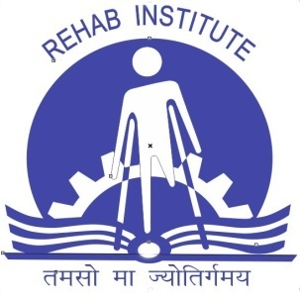
“ REGISTRATION FORM”
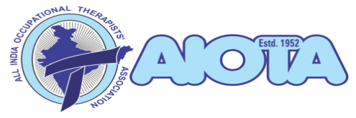
Continuing Occupational Therapy Education [COTE]
on
Wheelchair Seating & Mobility
[A certificate course]
Sat, Sept. 29, 2018

Organized by
All India Institute of Physical Medicine & Rehabilitation, Mumbai
in collaboration with
Academic Council of Occupational Therapy
Web site: www.aiota.org
Registration Form

PHOTO
FULL NAME: Dr.……………………………………………………………………………………………
MAILING ADDRESS: ………………………………………………………………………
………………………………………………………………………………………………………
E-MAIL: …………………………………………………………………………………………..
MOBILE NO: …………….…….............................. AIOTA MEMBERSHIP NO: ……………………………………………
EDUCATIONAL QUALIFICATIONS IN OCCUPATIONAL THERAPY:
Sr. No. | Name of the degree obtained | Year of Passing | Name of the college | Name of the University

TOTAL WORK EXPERIENCE IN YEARS: ……………………… Employed/Self Employed: ………………………………..
PAYMENT DETAILS: DD/NEFT/ net banking no: ………………………Name of the Bank & Branch: ………………………………………. Amount Rs:…………………………(in words………………………………….)

DATE: SIGNATURE OF THE APPLICANT
ATTACHMENTS:
Self-attested copies of:
- University Degrees or graduation passing certificate
- Certificate of AIOTA Life membership ( if any)
FEES: One-Time payment per participant including registration, certification, Transcript, Lunch & Tea during COTE day.
Early Registration (up to 20th August 2018)
AIOTA MEMBERS: Rs.1500/-
Non AIOTA Members: Rs.2000/-

Late Registration: (after 20th August 2018, subject to availability of seats)
AIOTA Members: Rs.2000/-
Non AIOTA Members: Rs.3000/-

Mode of Payment :

To be paid by DD or NEFT or direct transfer through net banking in favor of “ALL INDIA OCCUPATIONAL THERAPISTS’ ASSOCIATION”, payable at Mumbai.
BANK DETAILS
Name: Central Bank of India Branch: Mumbai Central , Mumbai
SB a/c No: 1026942763 IFSC Code No: CBIN0280601

Note: (GO GREEN)
- It is mandatory to only email the soft copy of duly filled application form along with scan copies of self-attested documents & DD Or Bank transaction receipt/ No ( in case of NEFT/net banking) to Anita Gupta: anita2004gupta@rediffmail.com & CC to Jyothika Bijlani, Dean ACOT: deanacot@aiota.org
- AIOTA reserves the right to accept /not accept any application on what so ever may be the reasons and decision to this regard shall be final and binding.
The DD with applicant’s name mentioned at the back side should be posted to
Dr. Jyothika Bijlani
Dean ACOT,
21, kalpataru Harmony, 105 B,
Sion East, Mumbai-400022
M: +91-9820964567
Email: deanacot@aiota.org

AIOTA Website: www.aiota.org [Registration Form may also be downloaded from AIOTA Website)

